SUMMER TRAINING/INTERNSHIP
PROJECT REPORT
(Term June-July 2025)

“ VOTE-XPRESS: AN INTERACTIVE ONLINE VOTING SYSTEM”

Submitted by
Aditya Raj - 12305995

Course: Advanced Data Structure
Course Code: PETV84

Under the Guidance of
Dr. Sarneet Kaur
School of Computer Science and Engineering

CERTIFICATE:-


ACKNOWLEDGEMENT:-

I express my sincere gratitude to my mentor and all faculty members of the School of Computer Science and Engineering for their continuous guidance and invaluable support during the completion of this project. Their expert insights and constructive feedback helped shape this project into a meaningful learning experience. I would also like to extend special thanks to my friends and family for their encouragement and patience throughout the development cycle.

TABLE OF CONTENTS :-

Chapter 1: Introduction
Chapter 2: Training Overview
Chapter 3: Project Details
Chapter 4: Implementation
Chapter 5: Results and Discussion
Chapter 6: Conclusion

Chapter 1: INTRODUCTION:-

Company Profile:
This project was undertaken by Aditya Raj and Mihir Anand under the guidance of Dr. Sarneet Kaur as part of their summer internship. It focused on solving a real-world voting problem by creating a fully interactive, AI-supported desktop application.
Overview of Training Domain:
The project was developed in Python using the Tkinter library for GUI design. The domain includes real-time voting mechanisms, civic education through quizzes, and AI chatbot integration. Topics like event-driven design, feedback handling, and modular programming were covered.
Objective of the Project:
To develop a secure and engaging digital voting system that streamlines voting processes for institutions, ensures vote integrity, and includes interactive tools like feedback, quizzes, and AI chat.

Chapter 2: TRAINING OVERVIEW:-

Tools & Technologies Used:
- Python 3.12
- Tkinter (GUI)
- threading, json, math
- Google Gemini API
- Visual Studio Code
Areas Covered During Training:
- GUI design using Tkinter
- Event-driven programming
- AI chatbot integration
- Quiz implementation
Daily/Weekly Work Summary:
Week 1: Project setup and splash screen...
Week 2: Registration and voting modules...
Week 3: Result display and admin panel...
Week 4: Feedback, quiz, and testing...
Chapter 3: PROJECT DETAILS:-

Title of the Project:-
VOTE-XPRESS: An Interactive Online Voting System
Problem Definition:-
Conventional voting systems are tedious, resource-intensive, and prone to error. They also lack modern features like live results, automated validation, and remote accessibility. This project offers a GUI-based solution that overcomes these problems.
Scope and Objectives:-
- One-person-one-vote enforcement
- Live vote counting and display
- Feedback collection
- AI chatbot for help and information
- Quiz to promote civic awareness
System Requirements:-
- OS: Windows/Linux/Mac
- Python 3.10+
Required Libraries:
Tkinter, requests, json, math, datetime, threading
Data Flow / UML Diagrams
- Register: Accept name and voter ID
- Vote: Cast vote if ID not used before
- Admin: Access result using password
- Feedback: Text and rating submission
- Quiz: MCQ based, time-limited
- Chatbot: Sends request to Gemini and shows answer

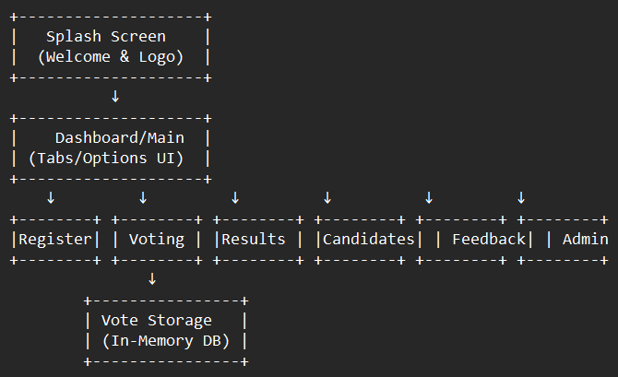

- Architectural Design Diagram

- DFD (Data Flow Diagram – Level 1)
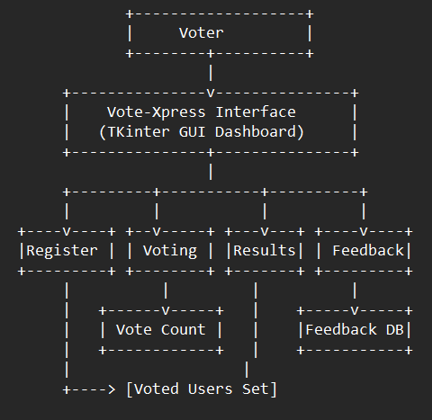

- UML Diagram (Class-Based - Simplified)
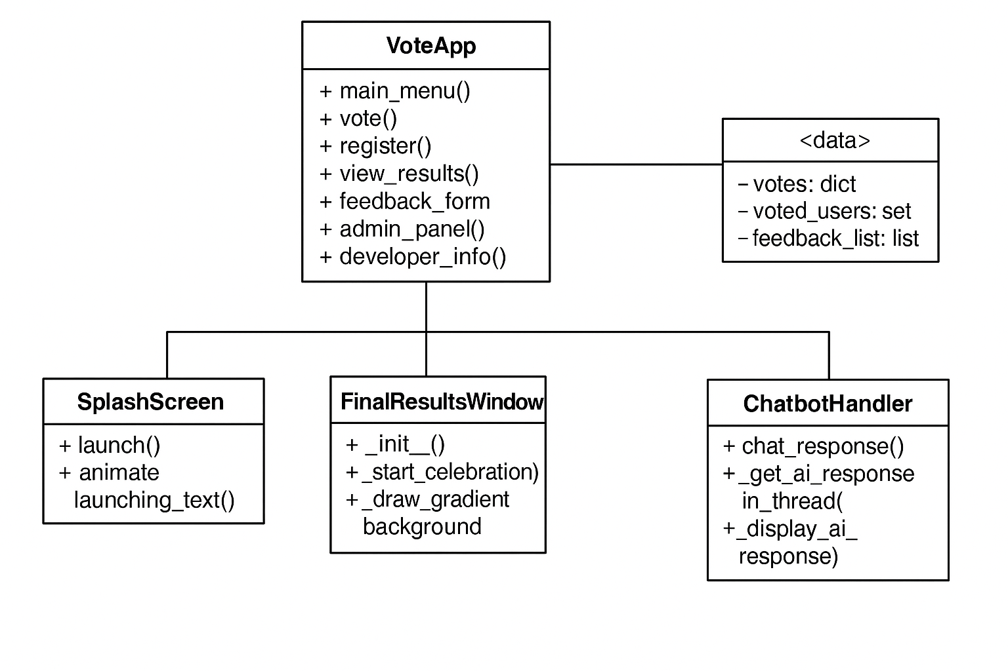
Chapter 4: IMPLEMENTATION
Tools Used:
Python (with Tkinter)
Gemini API for AI chatbot
Visual Studio Code/IDLE
Methodology:-
An event-driven modular approach was used. Each module (e.g., vote, feedback, chatbot) has its own function or class. Real-time updates are done through label manipulation and timers. Gemini API was integrated using requests with JSON payloads.
Modules and Functional Details:-
- Splash Screen: Animated welcome with Digital India theme
- Register Tab: Collects and validates user info
- Vote Tab: Shows candidate options; prevents repeat votes
- Results Tab: Shows winner with animations
- Admin Panel: Password-protected access to final result
- Quiz Tab: 10 questions, scoring and star badge display
- Feedback: Collects rating and remarks
- Chatbot: Sends user message to Gemini API, returns answer

4.1 Modules/Screenshots :-

- App Open
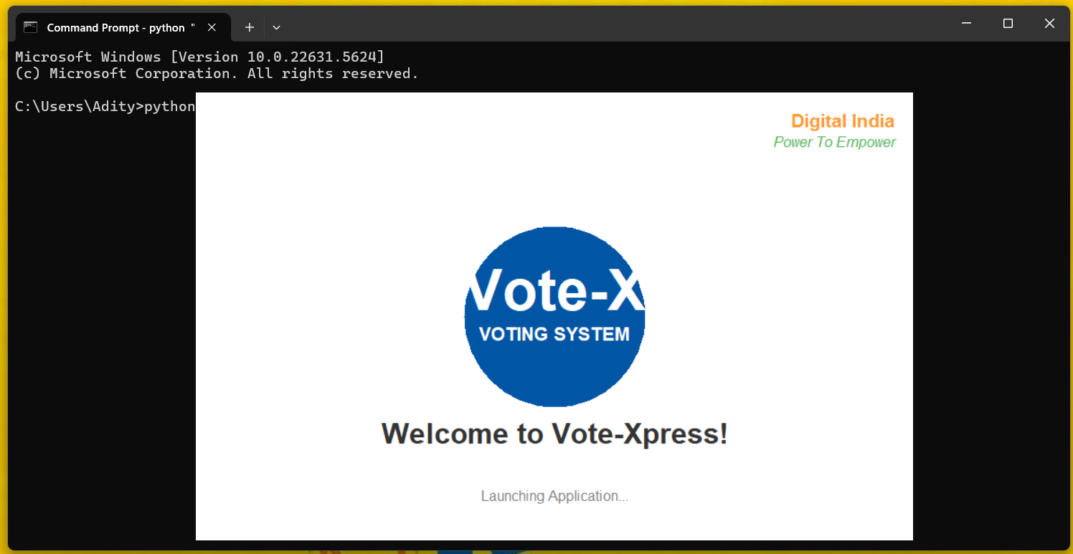
- Dashboard of the Application(With ChatBot)
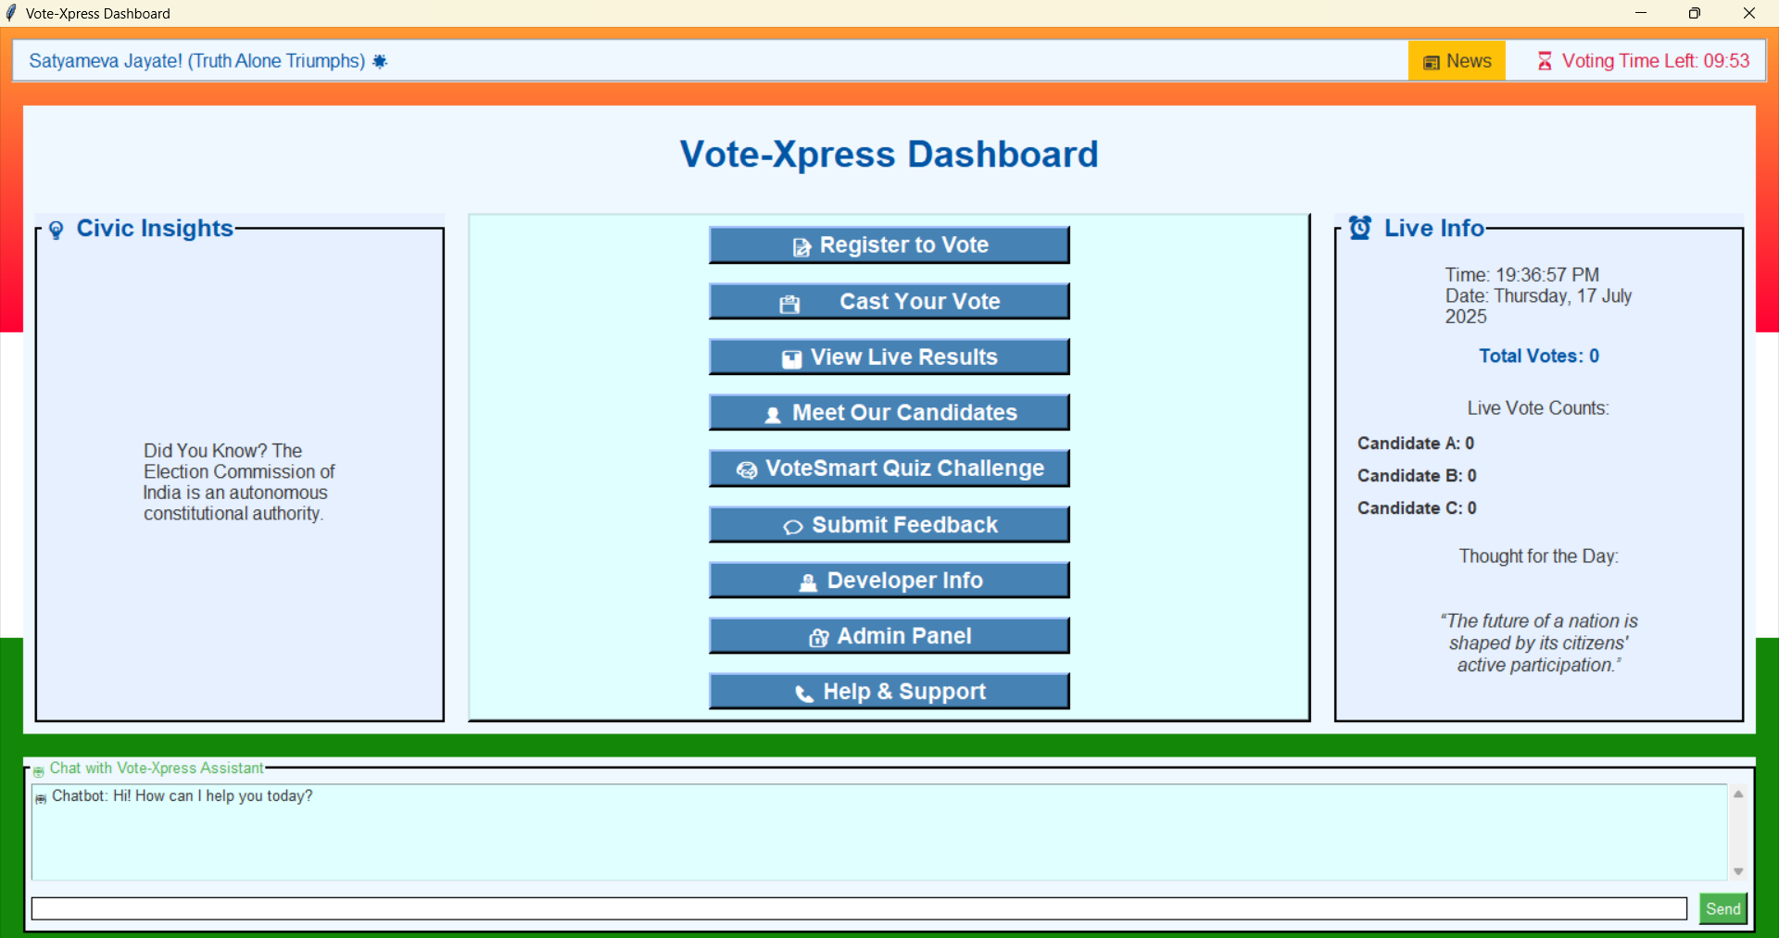

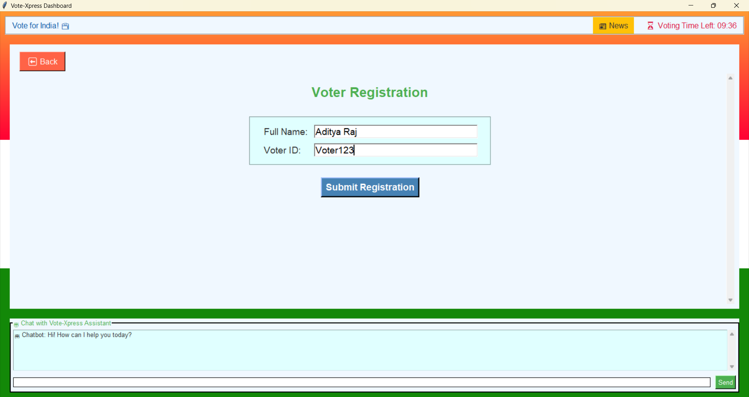
3.)Voter Registration
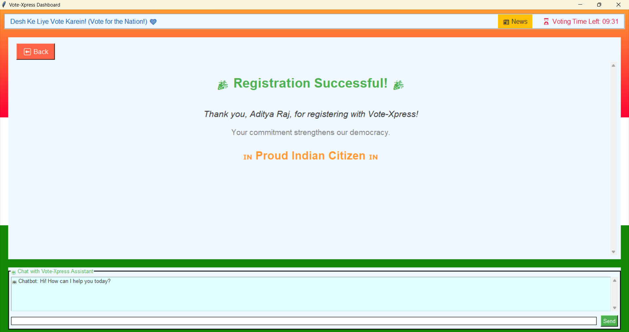
4.) Successful Voter Registration
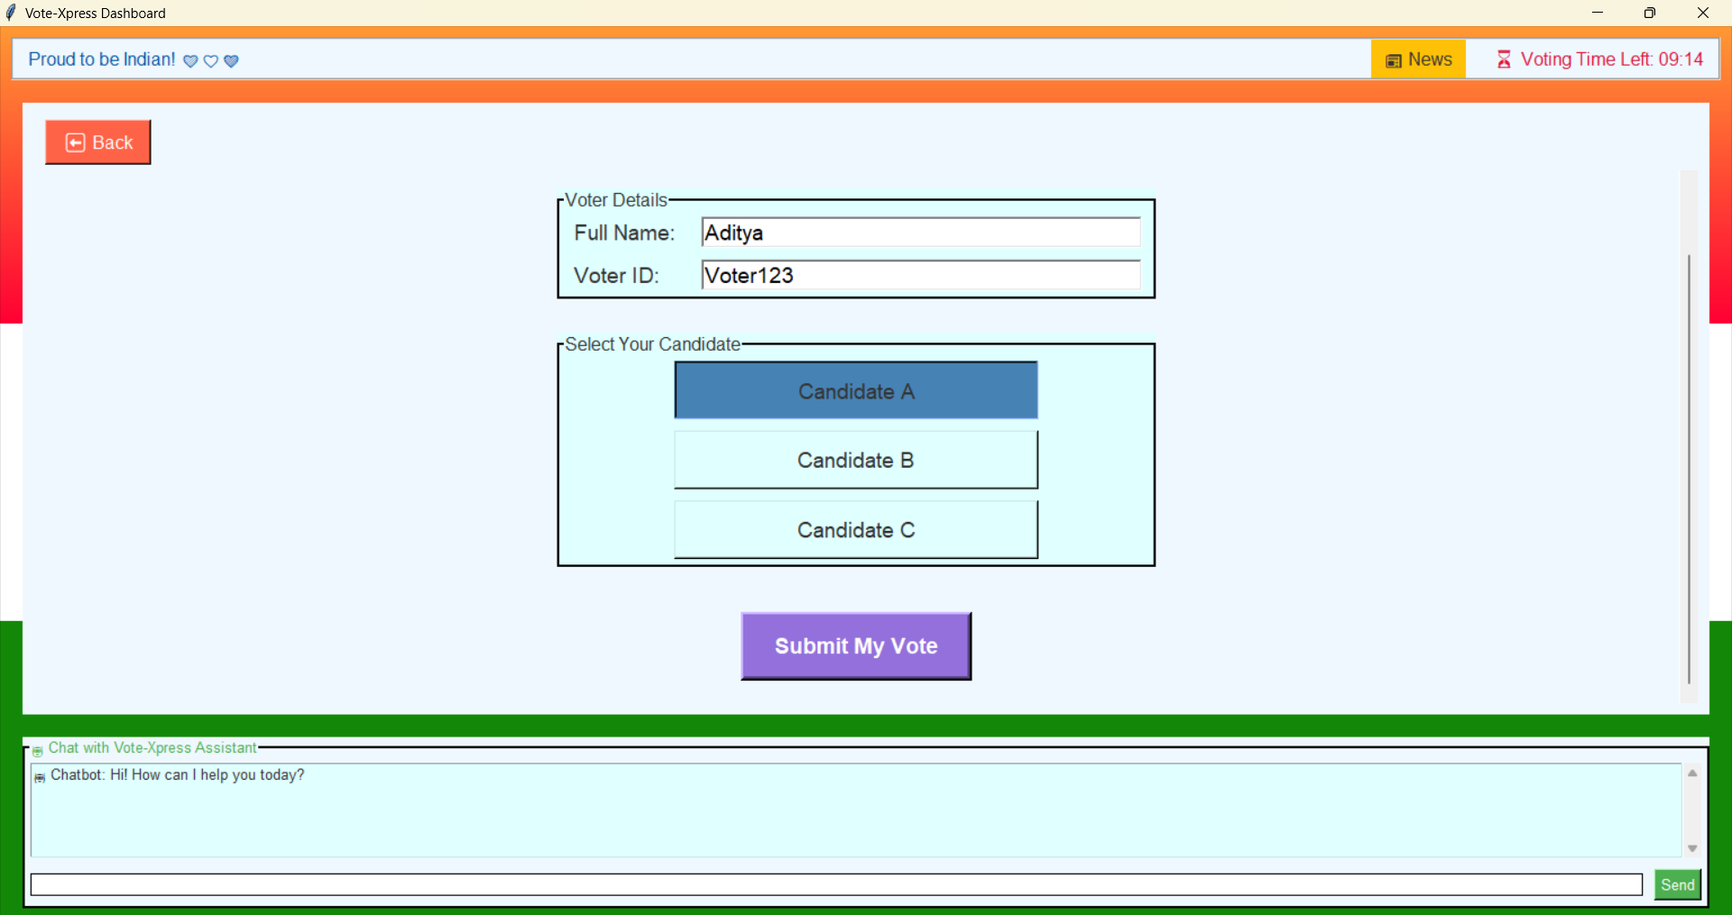
5.) Vote Cast Tab

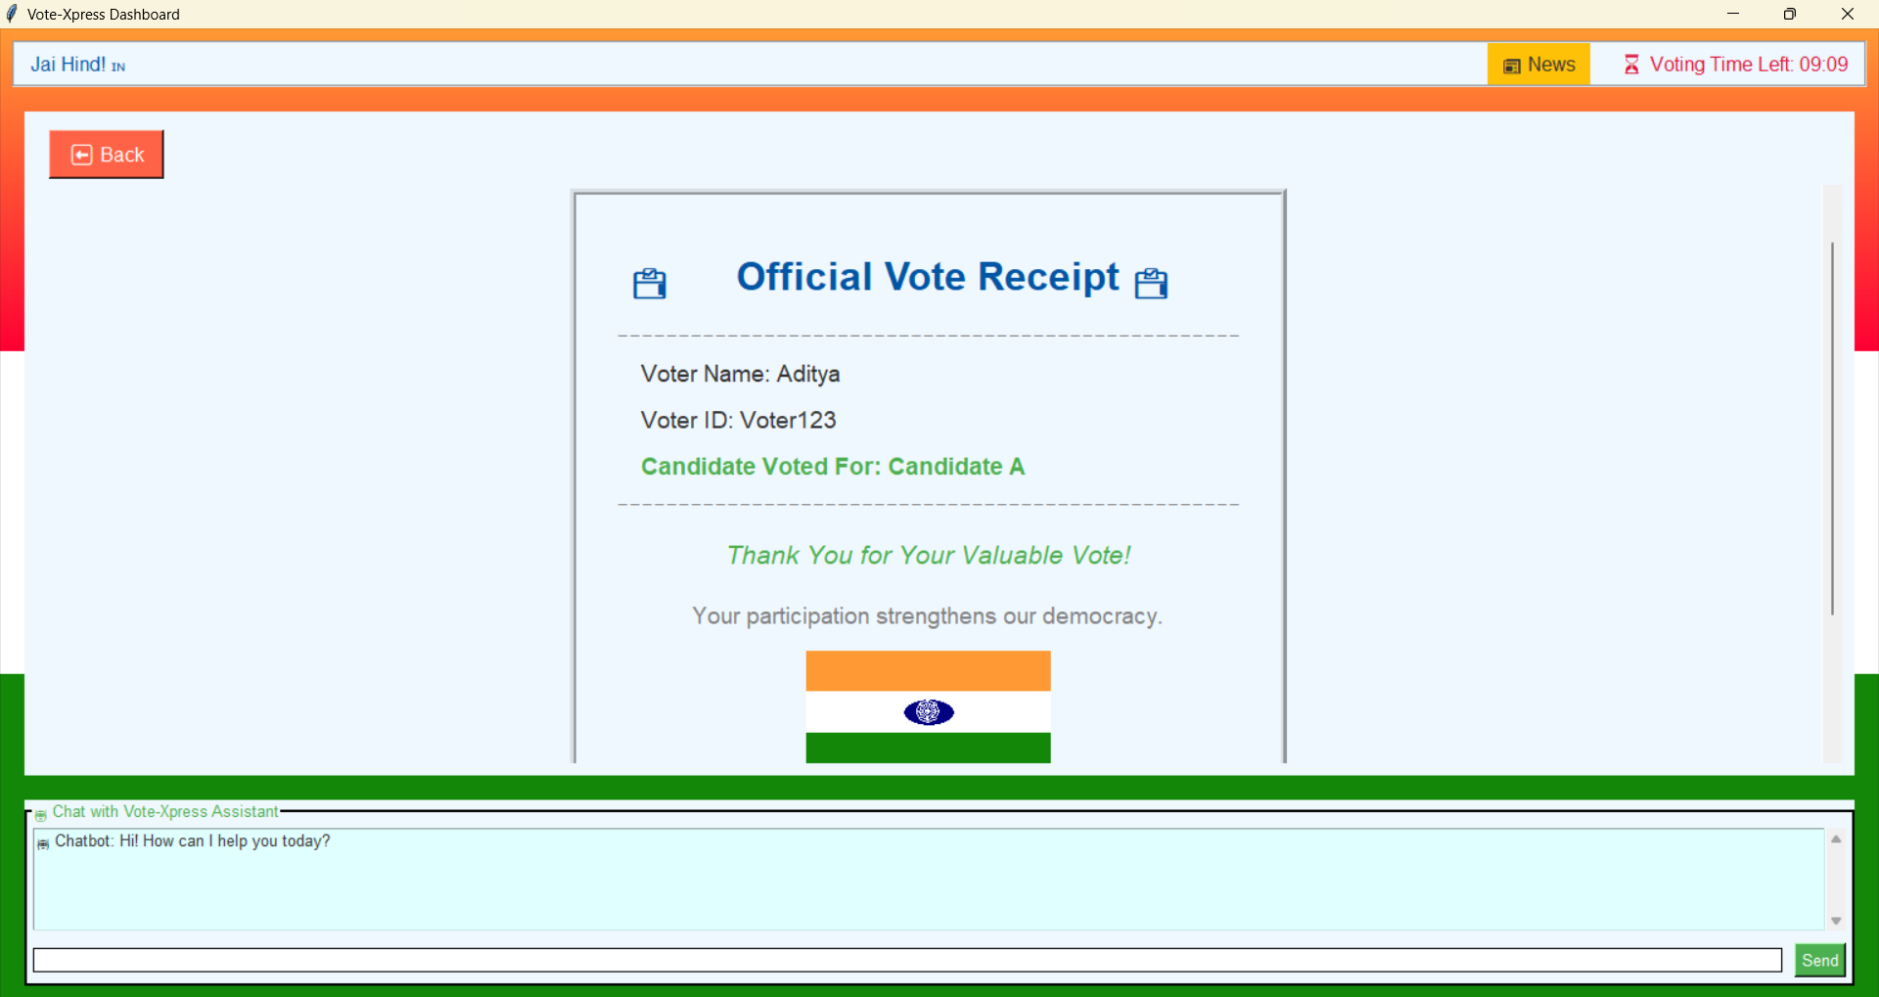
6.) Successful Vote Receipt

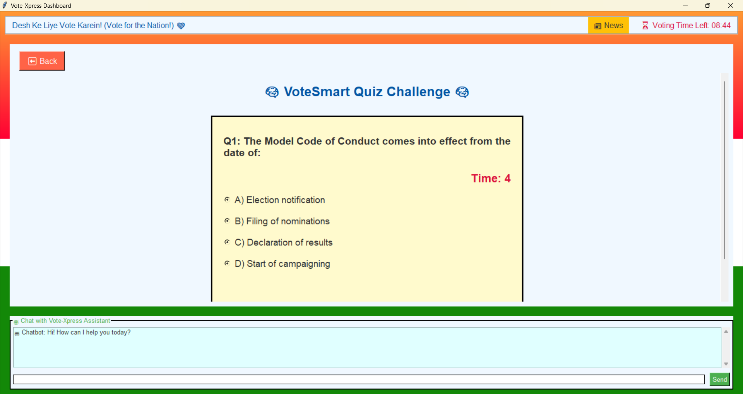
7.) Quiz/Game Tab (for voter)
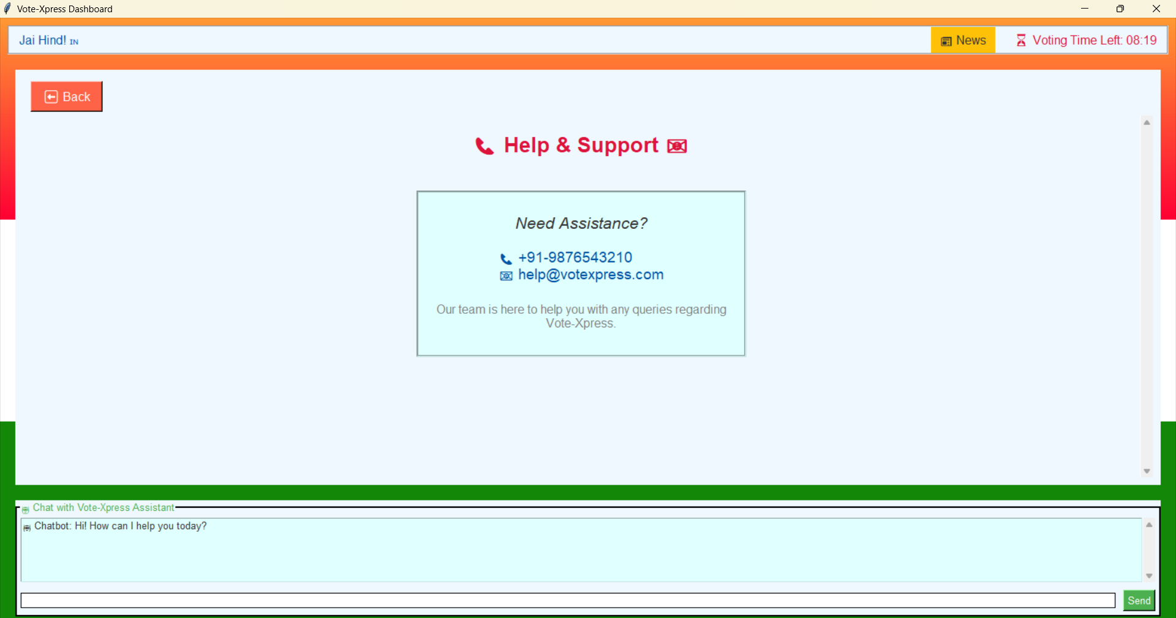
8.) Help/Support Tab(for Voter)

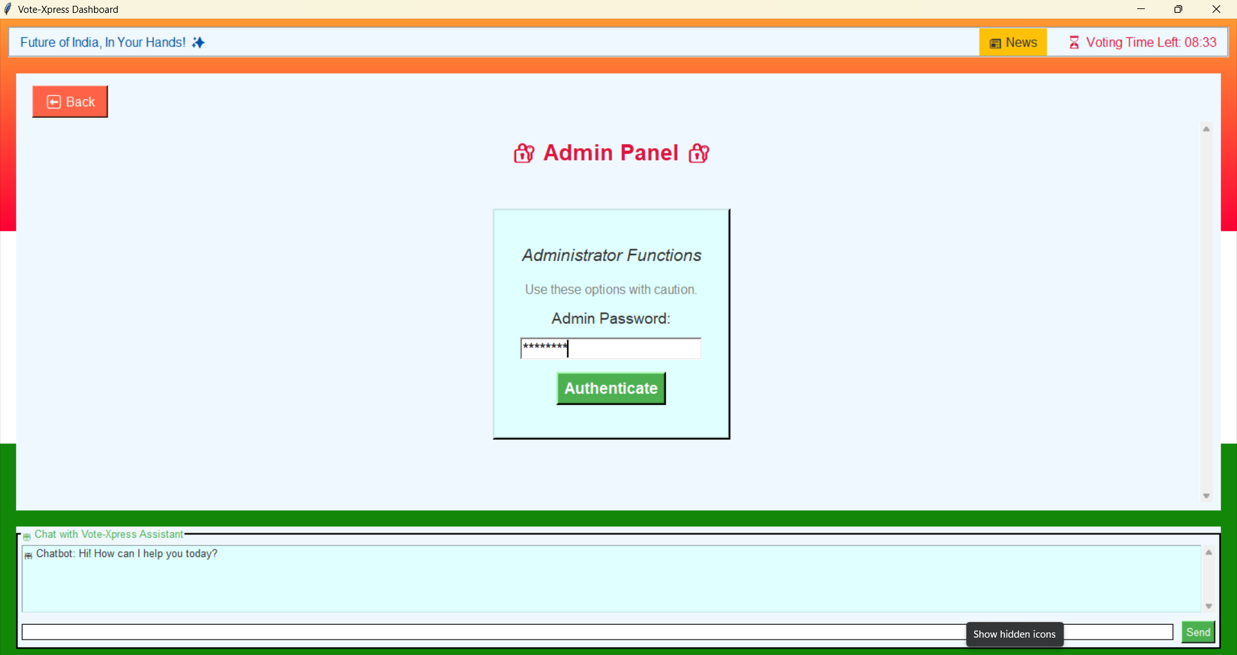
9.) Admin Panel(For Result Publish or any other things)
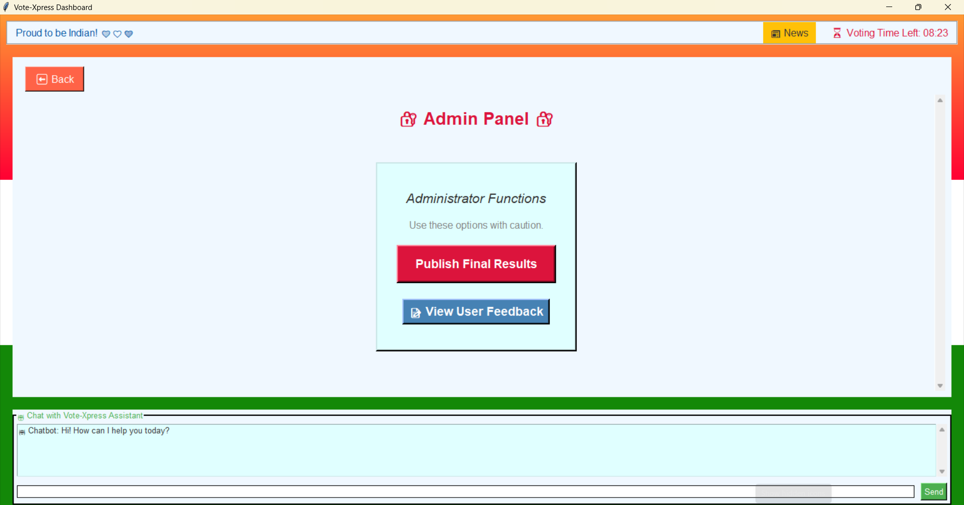
10.) Admin Panel tab
11.) Developer Information(With LinkedIn Tab)
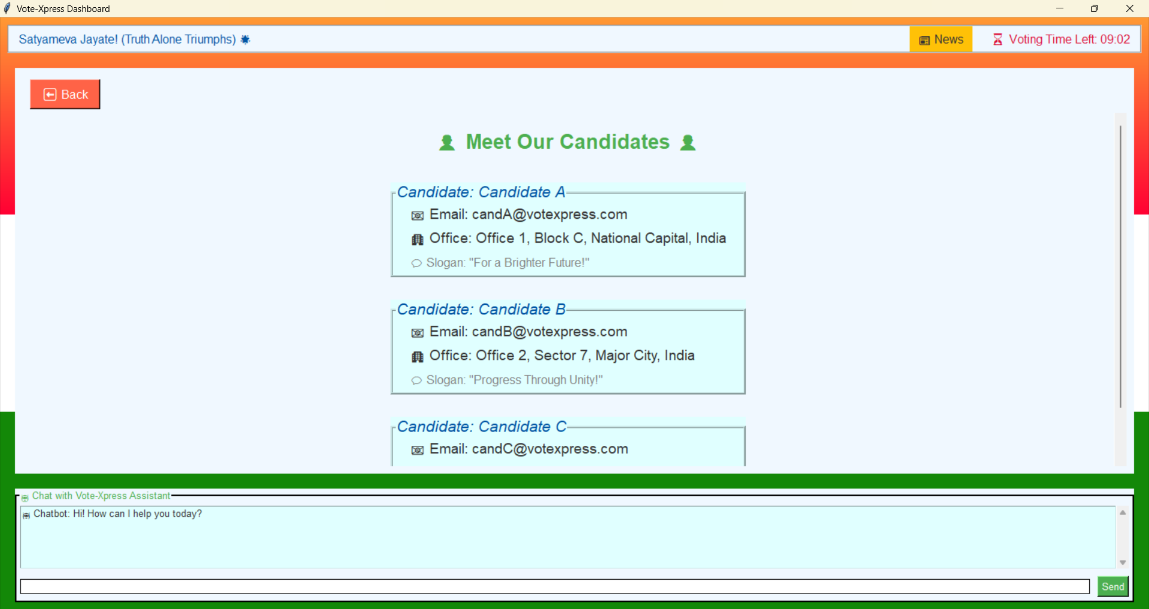
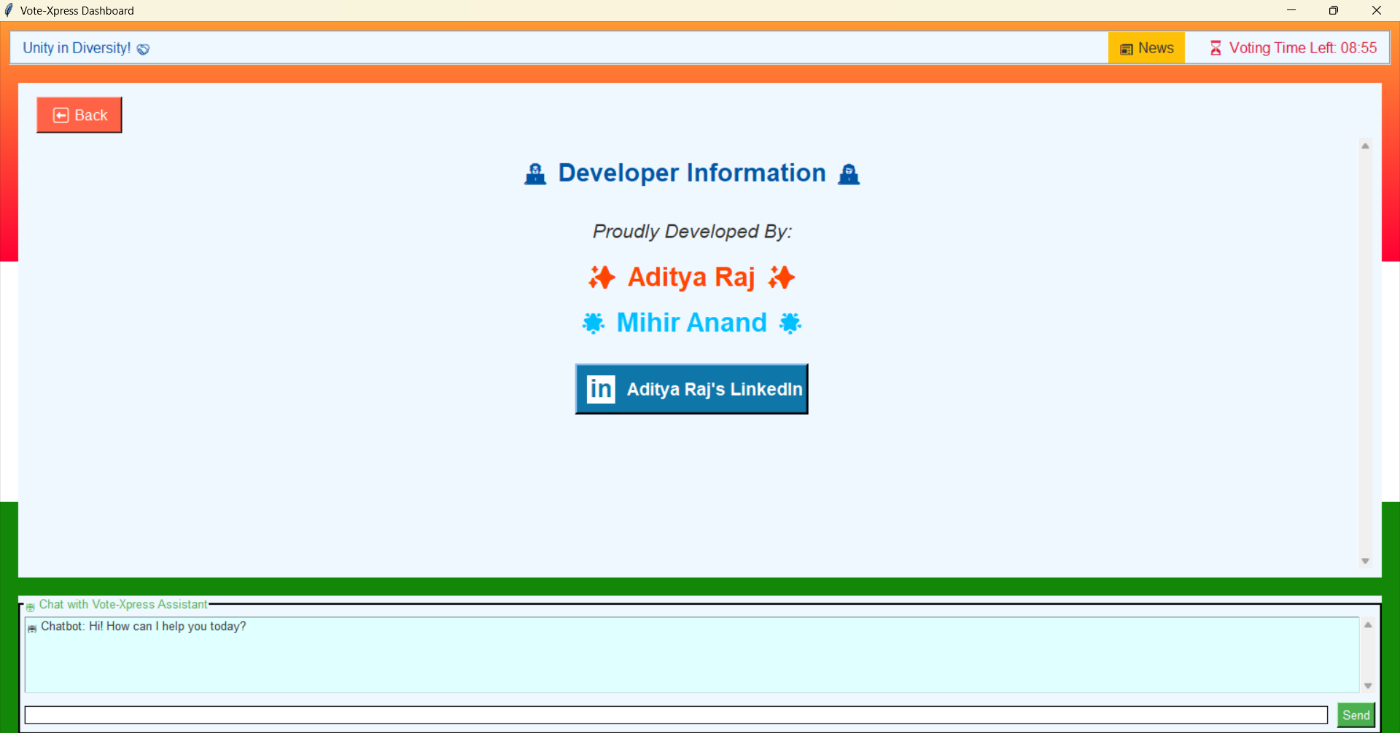
12.) Candidates details( To know Details about Candidates)

Chapter 5: RESULTS AND DISCUSSION:-
Output / Report:
- User registration works with validation
- Voting system records only one vote per user
- Quiz works with scoring and badges
- Chatbot integration successful via Gemini API
- Admin dashboard functions correctly
Challenges Faced:
- Handling asynchronous Gemini API calls in Tkinter
- Preventing UI freezing
- Managing real-time vote update without a database
- Quiz auto-advance and timeouts
Learnings:
- Tkinter layout and design patterns
- Multithreading in GUI
- External API integration
- Handling real-time user input and feedback

Chapter 6: CONCLUSION
Summary:
Vote-Xpress is a practical digital voting platform for academic institutions. It simulates real-world voting while also including learning and support components. This project demonstrates how full-stack application logic, UI design, and modern AI services can be integrated to solve civic problems efficiently.

